**COVID-19 ANALYSIS**

**ACM CLUB**

***CASE STUDY & REPORT***

**Team members**

| S.NO | Name | Reg-no | Role’s |
| --- | --- | --- | --- |
| 1 | Magapu Harsha | 19BCD7156 | Team Lead(CODE) |
| 2 | Satya Raj | 19BCD7041 | Preprocessing |
| 3 | Sreeharsha | 19BCD7114 | Dataset |
| 4  5  6  7.  8  9  10 | Sreekhar  Vivek  Aariz  Lokesh  Raghav  Navya  Niharika | 19BCE7081  20BCI7136  21BCE8053  21BCE8915  20BCE7383  21BCE7791  21BCE8053 | Dataset  Dataset  Case-Study, Report  Case-Study, Report  Case-Study, Report  Documentation  Documentation |

**SUMMARY ->**

At the end of this covid-19 analysis project we will be able to observe and learn how to conduct data visualization and get hands-on experience with various packages in python programming language. Also, an understanding on the data and work on real life word projects.

**SCOPE ->**

The objective of this research article and project is to find a prototype intelligent covid-19 system to tell the occurrence of high number of cases in different region in India and take more precautions. This system can extract hidden knowledge (pattern and relationships ) associated with covid-19 from the given historical covid-19 infectious disease database.

**INTRODUCTION:**

Coronavirus disease (COVID-19) is an infectious disease caused by the SARS-CoV-2 virus.

Most people infected with the virus will experience mild to moderate respiratory illness and recover without requiring special treatment. However, some will become seriously ill and require medical attention. Older people and those with underlying medical conditions like cardiovascular disease, diabetes, chronic respiratory disease, or cancer are more likely to develop serious illness. Anyone can get sick with COVID-19 and become seriously ill or die at any age.

The best way to prevent and slow down transmission is to be well informed about the disease and how the virus spreads. Protect yourself and others from infection by staying at least 1 metre apart from others, wearing a properly fitted mask, and washing your hands or using an alcohol-based rub frequently. Get vaccinated when it’s your turn and follow local guidance.

Our main goal is to predict whether patients have COVID-19 by given some features of users. This in turn will help to provide effective treatment to patients and avoid severe consequences. This is important to medical fields. If such a prediction is accurate enough, we can not only avoid wrong diagnosis but also save human resources. When a patient without a COVID -19 is diagnosed with COVID-19, he will fall into unnecessary panic and when a patient with COVID-19 is not diagnosed with COVID-19, he will miss the best chance to cure his disease.

**Objective:**

The goal of our COVID-19 analysis project is to determine if a patient should be diagnosed with COVID_19 or not. Our analysis can answer the complex queries for diagnosing COVID-19. Therefore, it can be helpful to health care practitioners to make intelligent clinical decisions.

Dataset:

The dataset has been taken from Kaggle.

LIBRARIES IMPORTED :

1. **Pandas ->**

* Pandas Is a software library written for python programming, for data manipulation and analysis.
* It is widely used for data structures and operation for manipulating numerical tables.
* Reshaping and pivoting of data set, fancy indexing, label slicing column insertion and deletion etc.

1. **Matplotlib ->**

* Plotting library for python programming, provides and object-oriented application programming interface for embedding plots.
* Provides various forms for plotting a graph for numerical tables like line plot, histogram,

scatter plot contour plot etc.

1. **NumPy ->**

* NumPy adds support for large multidimensional array and matrices, along with a large collection of high-level mathematical functions to operate on these arrays.
* Core function of NumPy is “ndarray” for n-dimension array, data structure.

1. **os->**

* os is a core python module that allows OS-specific tasks.
* Can be used to read all lines in a file or just open the file and create temporary files and directories, handling for high-level files and directory, manipulating paths.

**Analysis:**

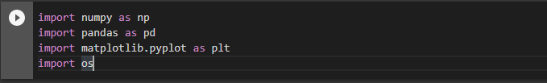

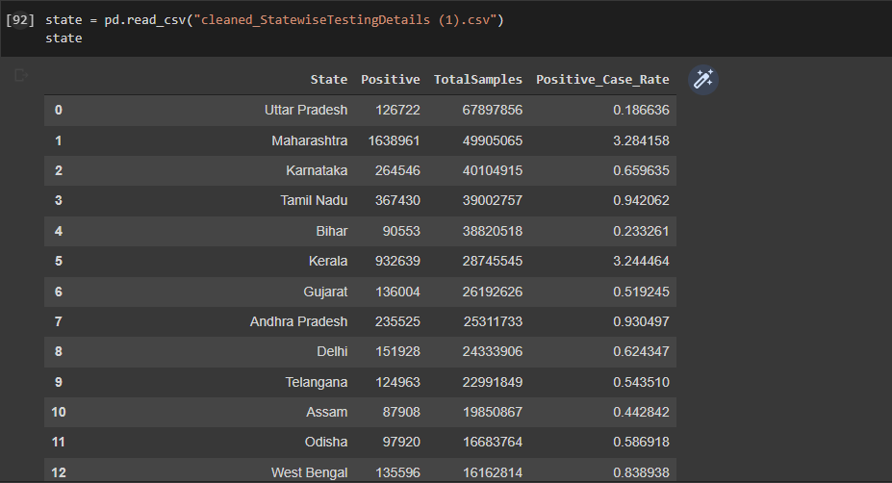

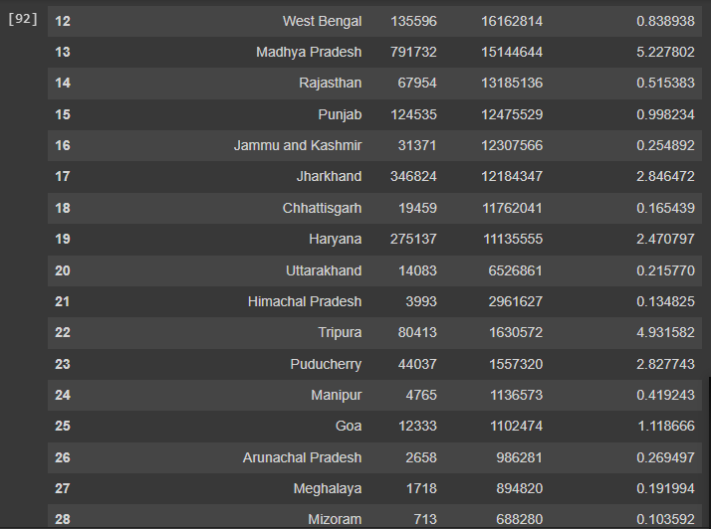

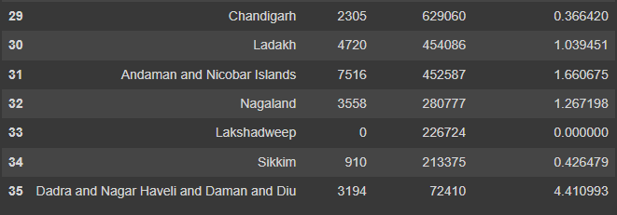

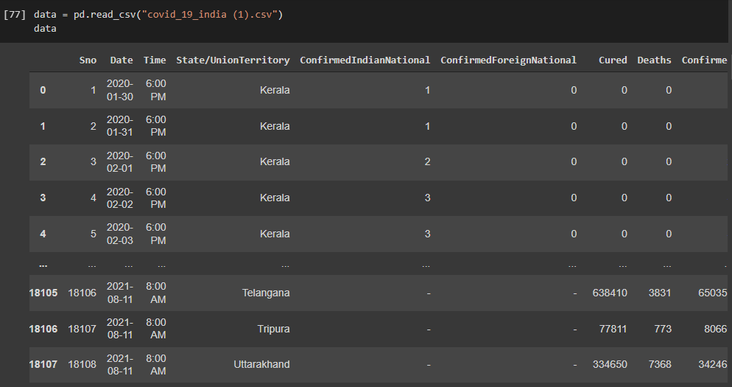

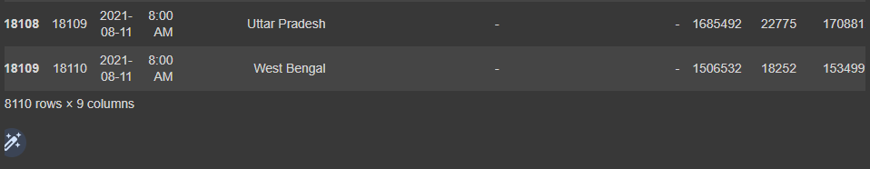

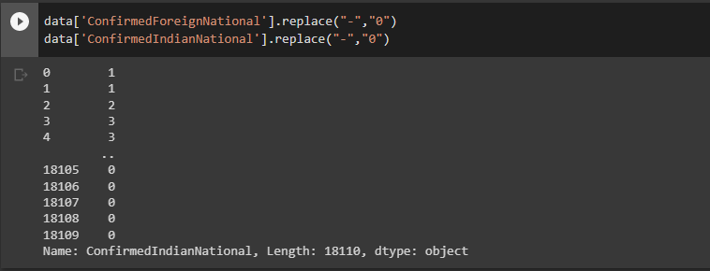

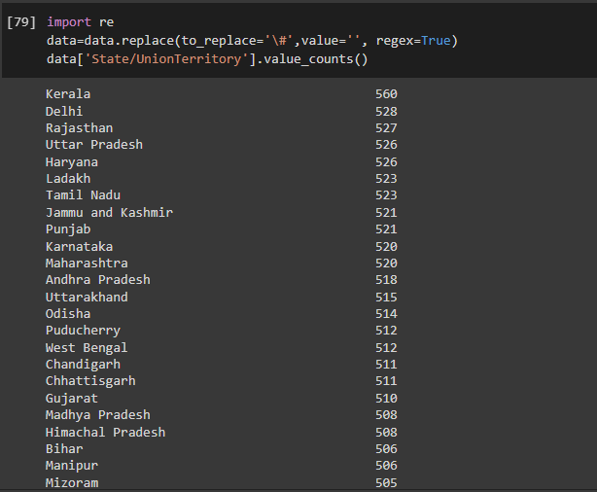

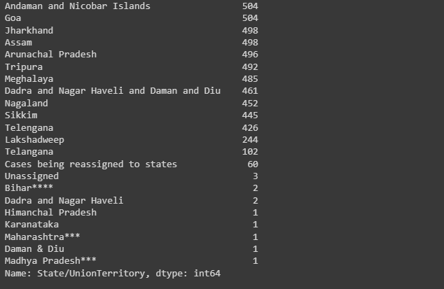

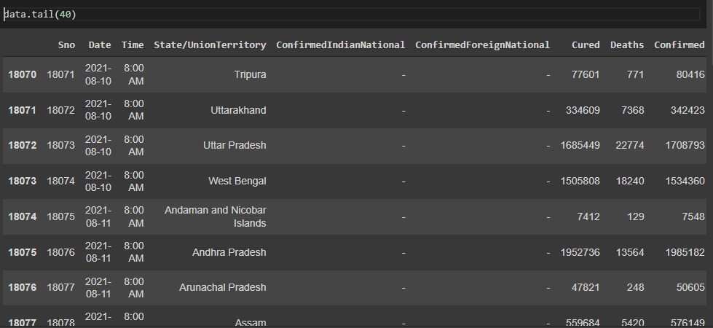

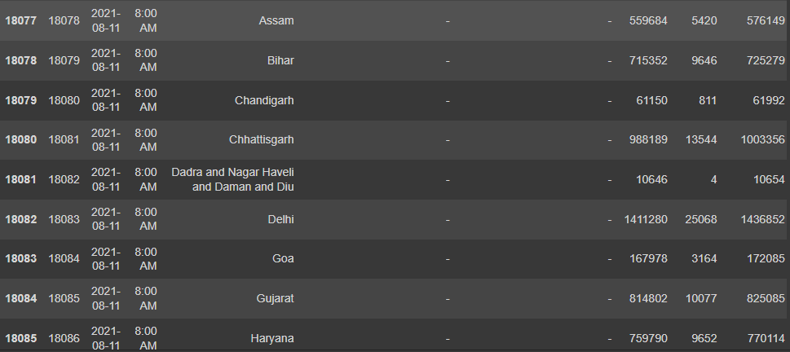

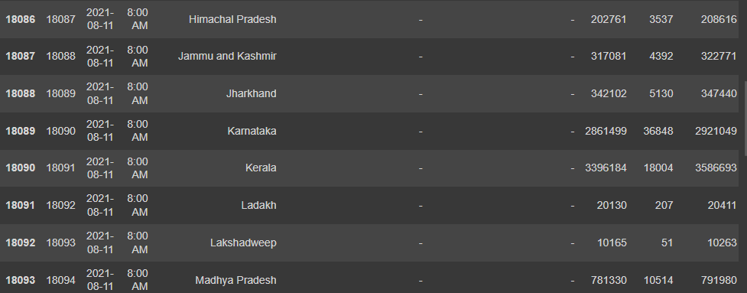

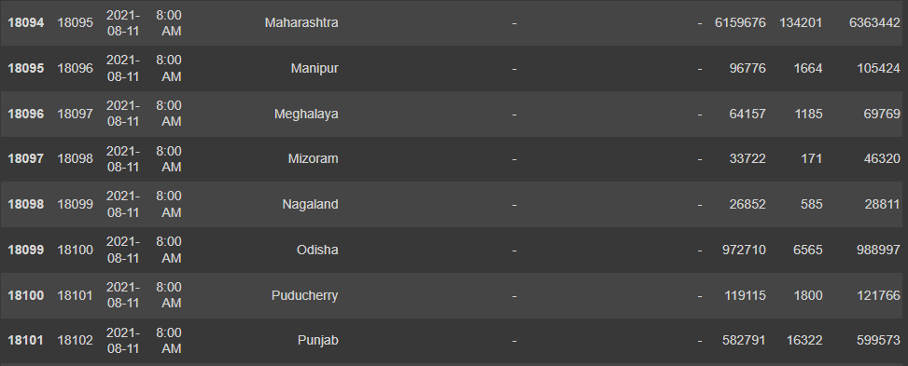

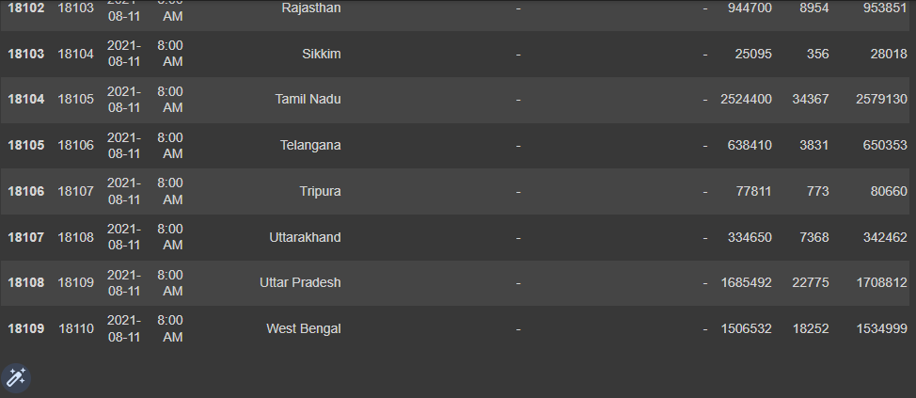

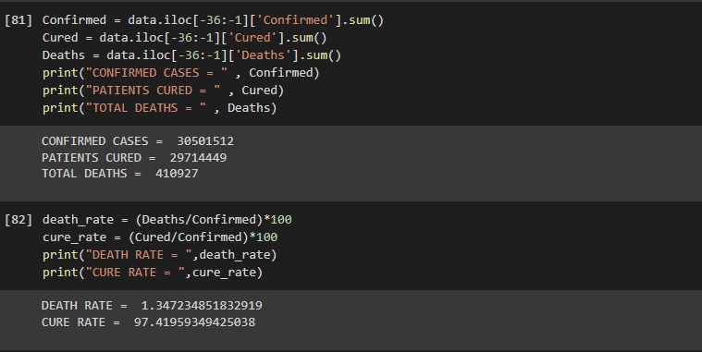

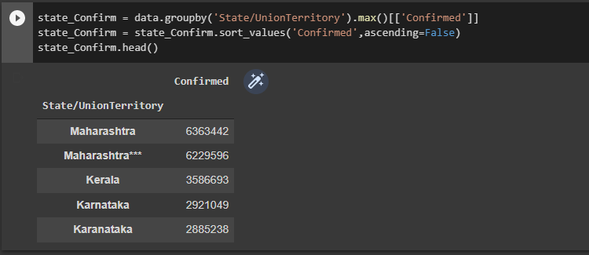

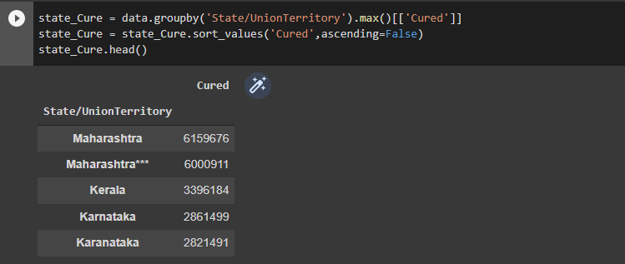

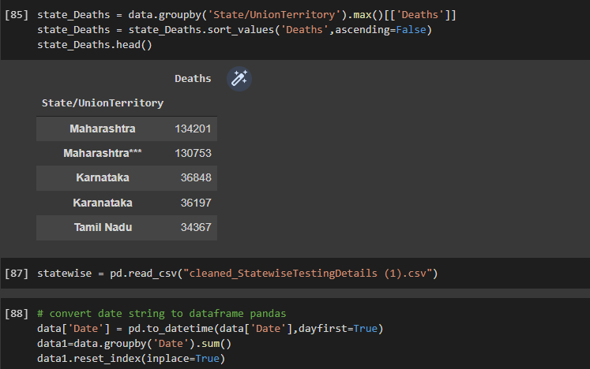

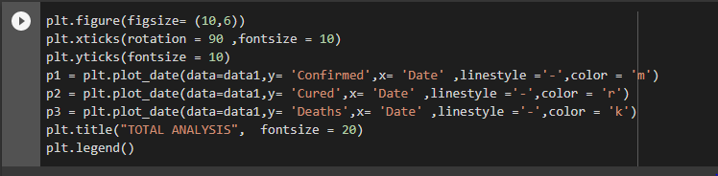

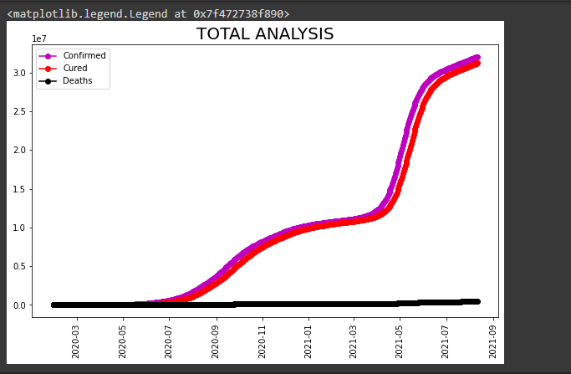

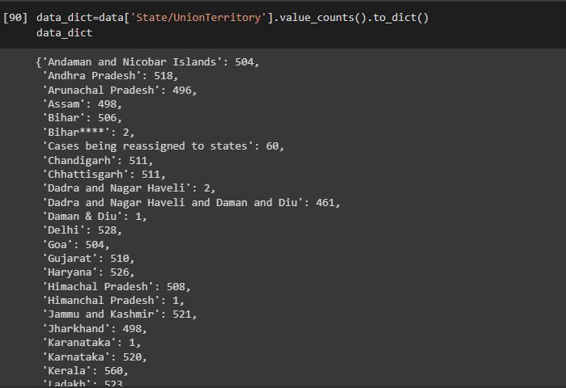

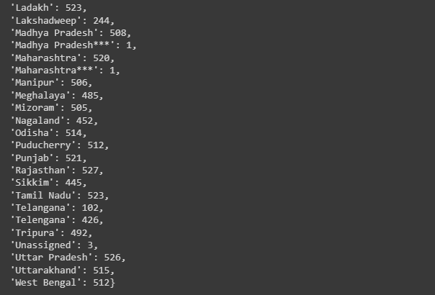

Conclusion:

So, we conclude by saying that this project Covid-19 analysis is extremely

much useful for drawing attention of the public to take precaution against Covid disease and it's also mainly important for the healthcare sector, because they're the one that do extra care for patients in the disease, using their general information and their symptoms that they been through. The distributions of states is analysed, and the conclusion is drawn. The conclusion which we found is that which state has highest Confirmed cases, recovered cases and death rate.

References:

Coronavirus (who.int)

Acknowledgement:

The satisfaction that accompanies that the successful completion of any

task would be incomplete without the mention of people whose ceaseless

cooperation made it possible, whose constant guidance and

encouragement crown all efforts with success. We are very grateful to

our project guide, for the help and support for our project work.